**Beauty Salon Management System**

**Salon Application**

**Mobile Application Development**

By

Karishma Patel (2095078)

1. **System Planning**
   1. **Business Case**

The Mobile Salon Management System addresses the need to streamline and enhance the salon experience for customers and staff. The project justification is based on:

* **Convenience for customers:**
  + Providing a user-friendly platform for online appointment booking and access to salon information.
  + Meeting the increasing demand for digital solutions in the beauty and wellness industry.
* **Effective Salon Administration:**
  + Empowering salon staff and administrators with tools for efficient appointment scheduling, staff management, and service integration.
  1. **SWOT Analysis**
* **Strengths:**
  + User-friendly interface for both customers and staff.
  + Integration of online booking, enhancing customer experience.
* **Weaknesses:**
  + Initial setup and potential resistance to digital transformation.
* **Opportunities:**
  + Potential for increased customer engagement through digital solutions.
  + Business growth through positive customer reviews and improved efficiency.
* **Threats:**
  + Competition from other salon management systems.
  + Technological challenges during implementation.
  1. **Constraints**
* **Time Constraints:**

The project must be completed within a specified timeframe. Delays may impact other aspects of the project.

* **Budget Constraints:**

Limitations on financial resources allocated to the project. This includes funding for development, testing, and other project-related activities.

* **Technology Constraints:**

Limitations imposed by the technology environment, including compatibility issues, platform restrictions, and hardware/software dependencies.

* 1. **Feasibility**
* **Technical Feasibility:** The project aligns with technological requirements.
* **Operational Feasibility:** The system enhances operational efficiency for salon staff.
* **Economic Feasibility:** The benefits outweigh the costs, considering potential business growth.
  1. **Project Management**
* **Roles and responsibilities:**
* **Timeline:**

Phase 1 (User Login and Registration): Feb 19 - Feb 26

Phase 2 (Home Page, Menu bar, Fragments): Feb 27 - March 19

Phase 3 (Appointment Booking, Feedback): March 20 – April 8

1. **System Analysis**
   1. **Who, What, Where, When, How, and Why?**

* **Who:** Customers, Salon Staff, Administrators
* **What:** Salon Management System with online booking and detailed service information.
* **Where:** Mobile devices, accessible from anywhere.
* **When:** Real-time access to appointment schedules.
* **How:** User-friendly interface for ease of use.
* **Why:** Addressing the demand for digital solutions and improving salon efficiency.

* 1. **Requirement Modeling**

**Outputs:**

**Appointment schedules:** The app should display a list of available services for booking appointments. After booking, users should be able to view their scheduled appointments, including the service, date, and time.

**Feedback submission:** Users should be able to provide feedback on their salon experience, including a rating and comments.

**Inputs:**

**User registration information:** Users should input their first name, last name, phone number, email, and password to register for the app.

**Login credentials:** Users should input their email and password to log into the app.

**Appointment booking:** Users should input their preferred service, date, and time when booking an appointment.

**Feedback submission:** Users should input their rating and comments when providing feedback.

**Processes:**

**User registration:** The app should process user registration information, validate inputs, create user accounts in the system, and securely store login credentials.

**User login:** The app should authenticate user credentials during login, allowing access to user-specific functionalities and data.

**Appointment booking:** The app should process appointment booking requests, check for availability, and schedule appointments accordingly.

**Feedback submission:** The app should process feedback submissions, store the feedback in the database, and associate it with the respective user and appointment.

**Performance:**

**Speed:** The app should respond promptly to user actions, such as registration, login, appointment booking, and feedback submission, to ensure a smooth user experience.

**Accuracy:** The app should accurately record user registration information, authenticate login credentials, schedule appointments correctly, and store feedback data without errors.

**Reliability:** The app should be available and functional without unexpected crashes or downtime, ensuring users can access it whenever needed.

**Usability:** The app interface should be intuitive and user-friendly, allowing users to navigate easily, log in securely, book appointments efficiently, and provide feedback effortlessly.

**Security:** The app should ensure the security of user data, including registration details, login credentials, and feedback submissions, by implementing appropriate measures such as encryption, secure authentication protocols, and access control.

* 1. **Data and Process Modeling:**

**Data Modeling:**

**1. Identify Data Entities:**

**User:** Represents individuals who interact with the salon app.

Attributes: user_id, user_fName, user_lName, user_phone, user_email, user_pwd

**Feedback:** Represents feedback provided by users.

Attributes: id, userName, email, rating, comments

**Appointment:** Represents appointments booked by users.

Attributes: id, userName, service, date, time

**2. Define Relationships:**

**User-Feedback:** One-to-many relationship. Each user can provide multiple feedback.

**User-Appointment:** One-to-many relationship. Each user can have multiple appointments.

**Process Modeling:**

**1. Identify Processes:**

User Registration: Process of users registering for the app.

User Login: Process of users logging into the app.

Appointment Booking: Process of users booking appointments.

Feedback Submission: Process of users providing feedback.

**2. Define Process Flow:**

**User Registration:**

1. User provides registration details.
2. System validates input data.
3. System creates a new user account.
4. User receives confirmation.

**User Login:**

1. User provides login credentials.
2. System authenticates user.
3. User gains access to app features.

**Appointment Booking:**

1. User selects service, date, and time.
2. System checks availability.
3. System schedules appointment.
4. User receives confirmation.

**Feedback Submission:**

1. User provides feedback (rating and comments).
2. System stores feedback data.
3. Confirmation message is displayed.
   1. Modeling Documents:
4. **Functional Decomposition Diagram**

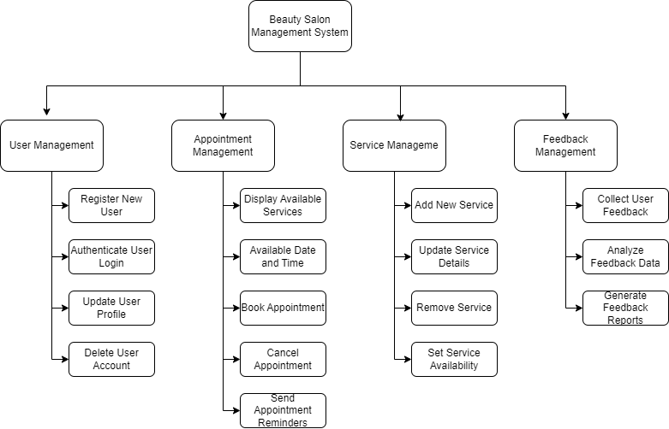

1. **Data Flow Diagram**

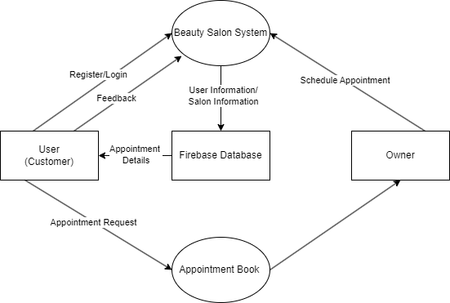

* 1. **Object Modeling using UML (Unified Modeling Language) notation**

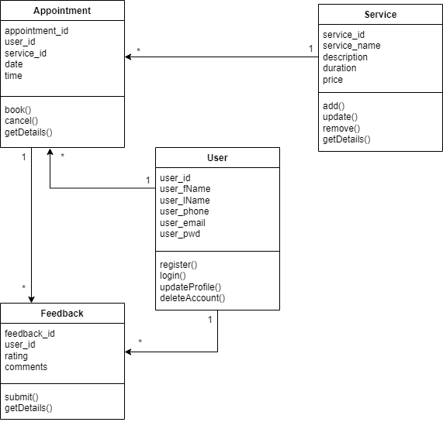

**Relationships:**

User has multiple Appointments (one-to-many association)

Appointment belongs to one User (many-to-one association)

Appointment is associated with one Service (many-to-one association)

Service has multiple Appointments (one-to-many association)

Feedback is given by one User (many-to-one association)

Feedback is associated with one Appointment (many-to-one association)

1. **System Design**

